# Global B - How to Add an External DTC

This document assumes you are starting with a baseline project with the latest ARXML database already integrated.

## Changes in DaVinci Configurator and Developer

### Configurator: Configuring the DEM

1. Open your project in DaVinci Configurator.
2. Synchronize and save the project, if necessary.
3. Open the Basic Editor.
4. Expand the following node:   
     
   Dem/DemConfigSet/DemEventParameters
5. Scroll down the list of DTCs and look for the one you are trying to add. It should already be in the list. Expand the node.
6. Click on the “DemCallbackEventStatusChangeds” node. Click on the ‘plus’ button to add a callback. The default name is fine.  
     
   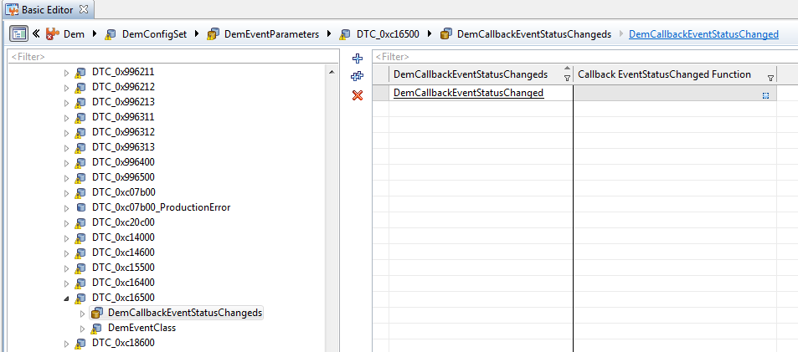
7. Synchronize and save the project again.
8. Click on the “DemEventClass” node. Set:  
     
   EnableCondition Group Ref = (Select the appropriate conditions for your particular DTC)  
     
   Event FailureCycle Ref = /ActiveEcuC/Dem/DemGeneral/IgnitionCycle  
     
   Event Priority = 1
9. Expand the Dem/DemConfigSet/DemEventParameters/DTC_0xcXXXXX/DemEventClass/DemDebounceAlgorithmClass/DemDebounceCounterBased node. Click on the node.
10. Set the following parameter values:  
      
    Debounce Behavior = DEM_DEBOUNCE_FREEZE  
    DebounceCounter Decrement Step Size = 128  
    DebounceCounter Failed Threshold = 127  
    DebounceCounter Increment Step Size = 127  
    DebounceCounter Passed Threshold = -128
11. Close the Dem node.

### Configurator: Configuring the SUM_ERRH

1. Expand the SwcSumGm/ERRH/ERRH_DTC_Triggered_Message/ERRH_Additional_DTCs node.
2. Click the ‘plus’ button and add the new DTC to the list.
3. Synchronize and save the project.
4. Close DaVinci Configurator.

### Developer: Configuring SWC_DTC_Handling

1. Open your project in DaVinci Developer.
2. In the Object Browser, open the Application Component Types/SWC_DTC_Handling node.
3. Open the Port Prototype List and select Service Ports.
4. Click the New button and select from Port Interface.
5. Select the DiagnosticMonitor port interface.  
     
   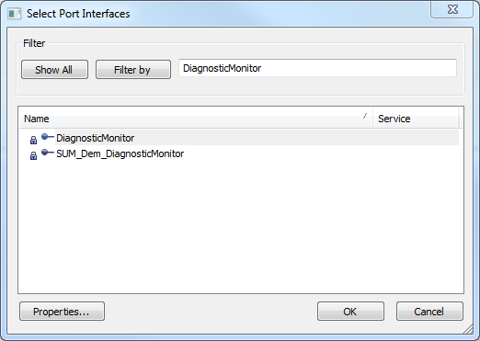
6. Change the port name and make sure that the direction is Client.  
     
   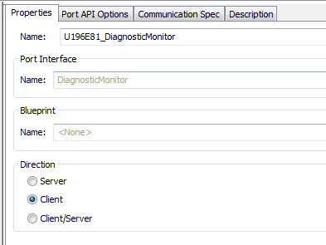
7. Open the Runnable Entity list and select the Diagnostic_TroubleCode_Monitor_500ms runnable.  
     
   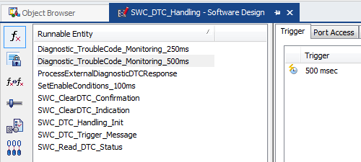
8. Open the Port Access tab.
9. Click the New button and select Invoke Operations.
10. Search for the Client Port Prototype for the DTC. Select the “SetEventStatus” operation prototype. Also change the Timeout unit to sec.  
      
    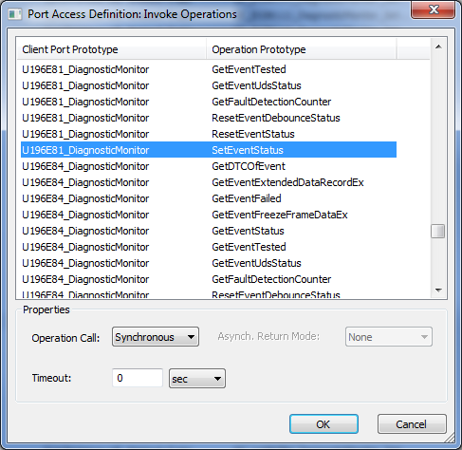
11. Select the SWC_Read_DTC_Status runnable.
12. Open the Port Access tab.
13. Click the New button and select Invoke Operations.
14. Search for the Client Port Prototype for the DTC. Select the “GetEventStatus” operation prototype. Also change the Timeout unit to sec.  
      
    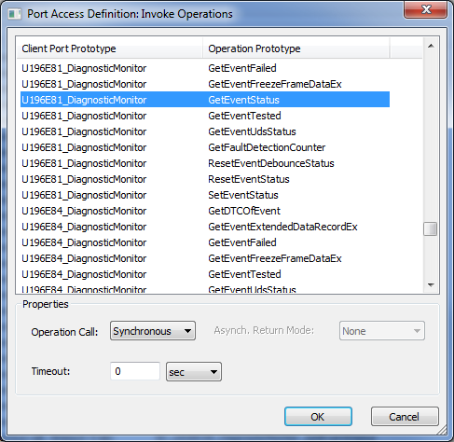
15. Save the project.
16. Close the SWC_DTC_Handling component.

### Developer: Configuring the DEM_SUMS_Adapter

1. In the Object Browser, open the Application Component Types/DEM_SUMS_Adapter node.
2. Open the Service Ports tab.
3. Open the Port Prototype list.
4. Click the New button and select From Port Interface.
5. Select the CallbackEventUdsStatusChanged port interface.  
     
   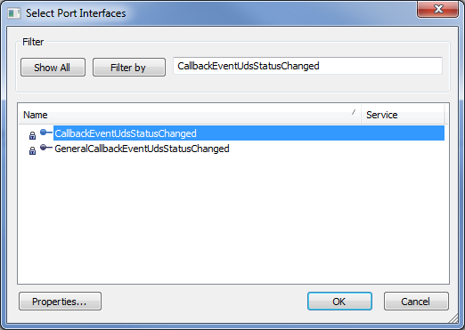
6. Change the port name to “CBEventUdsStatusChanged_DTC_0xXXXXXX_DemCallbackEventStatusChanged” and change the direction to Server.  
     
   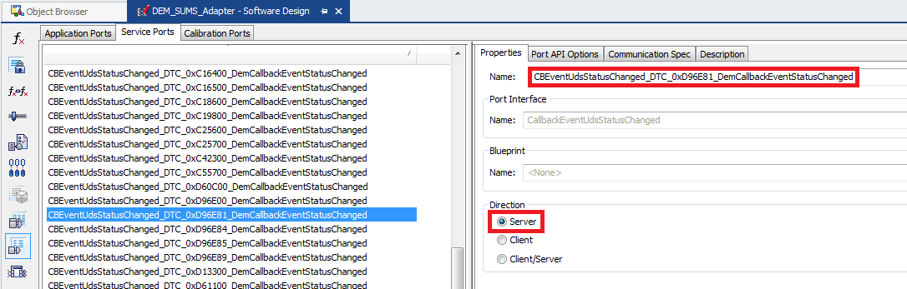
7. Click the New button and select From Port Interface.
8. Select the SUM_Dem_CallbackEventStatusChange port interface.  
     
   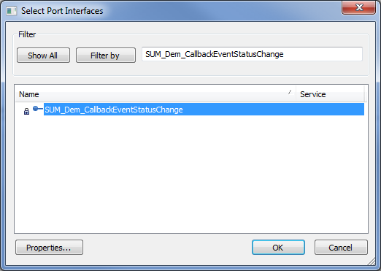
9. Change the name of the port to “DEM_CBStatusEvt_DTC_0xXXXXXX” and the direction to Client.  
     
   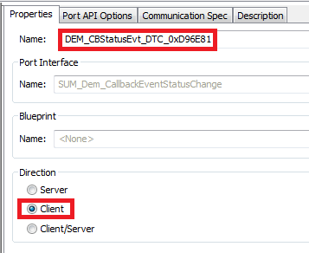
10. Open the Runnable Entity List.
11. Click the New button and select Server Runnables.
12. Select the new server port you just added. Keep the prefix and postfix empty.  
      
    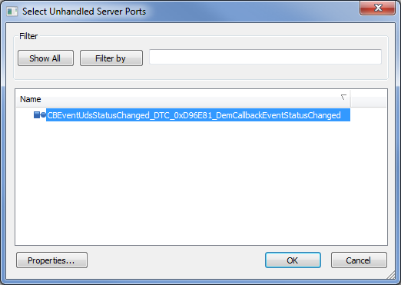
13. Click on the new Runnable Entity and open the Port Access tab.
14. Click the New button and select Invoke Operations.
15. Select the DEM_CBStatusEvt_DTC_0xXXXXXX client port prototype with Operation Type = EventStatusChanged. Change the Timeout unit to sec.  
      
    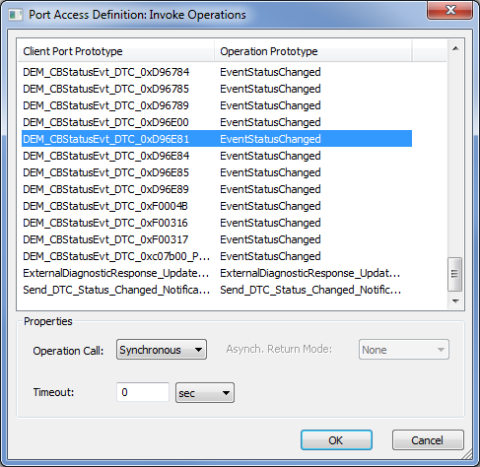
16. Save the project and close DaVinci Developer.

### Configurator: Connecting the Components

1. Open your project in DaVinci Configurator.
2. If necessary, synchronize and save the project.
3. Open Runtime System and select ECU Software Components.
4. Open the Service Components/DemMaster_0 node.
5. Select Service Ports.
6. Connect the CBEventUdsStatusChanged_DTC_0xXXXXXX_DemCallbackEventStatusChanged port to the correct port on DEM_SUMS_Adapter.  
     
   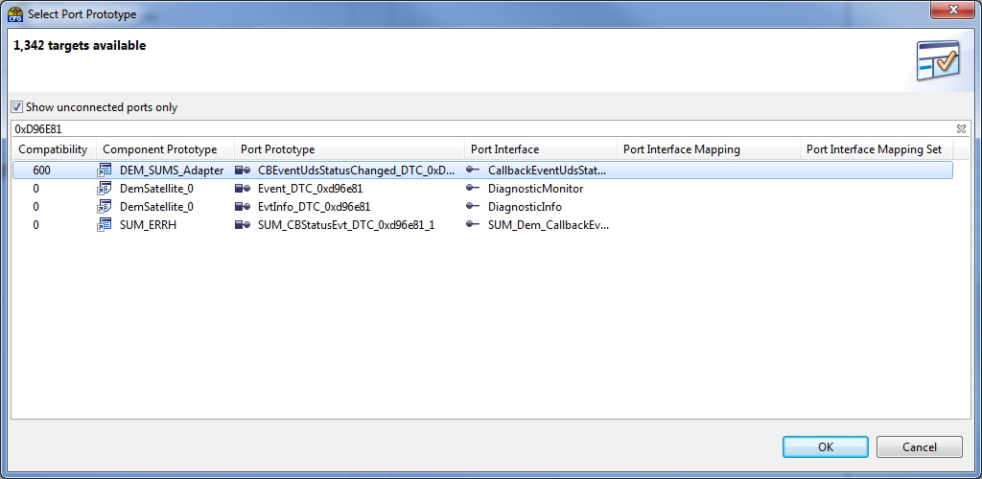
7. Open the DemSatellite_0 node.
8. Click on the Service Ports node.
9. Connect the Event_DTC_0xXXXXXX port prototype to the associated DiagnosticMonitor port on SWC_DTC_Handling.  
     
   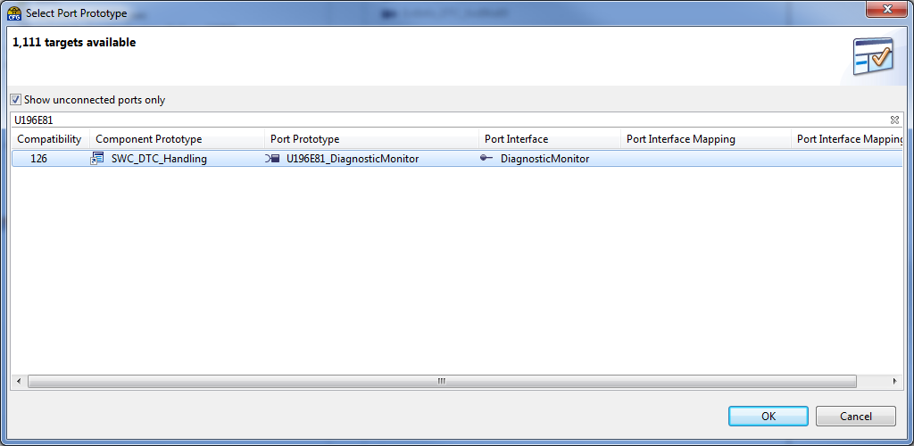
10. In ECU Software Components, open the Application Components/SUM_ERRH node.
11. Click on the Service Ports node.
12. Connect the SUM_CBStatusEvt_DTC_0xXXXXXX_1 port to the associated port on DEM_SUMS_Adapter.  
      
    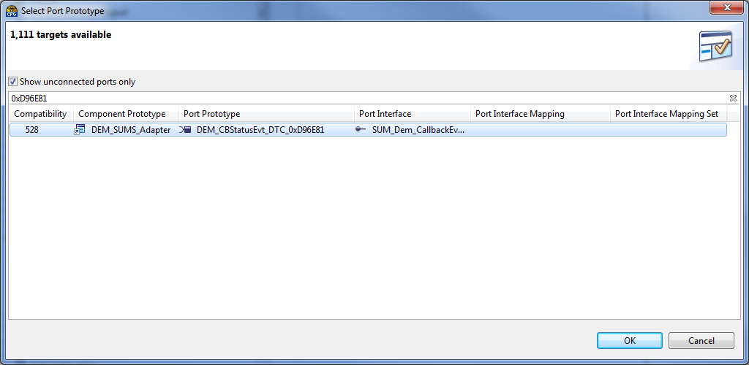
13. Save the project.

### Configurator: Generating the Code

1. Generate the code for SwcSumGm, Dem, and Rte.
2. Generate the Template File for DEM_SUMS_Adapter and SWC_DTC_Handling.
3. Save the project and close DaVinci Configurator.

## Manual Code Changes

1. If required, open \Appl\Source\DTC\dtc_list.h and add a DTC_DEF entry under the “Manual Entries” section at the bottom of the file. You will only need to do this if the DTC does not have a corresponding DTC_MASK calibration defined in the CalDef database. If you do need to add a DTC_DEF entry to the bottom of the file, just use the next available number for the statusBitPosition.
2. Edit \Appl\Source\SWC_DTC_Handling.c. Add a case statement for the new DTC to the switch block in the SWC_Read_DTC_Status() function.
3. In \Appl\Source\SWC_DTC_Handling.c, edit the MonitorExtDtcStatus function. Add the new DTC to the switch statement.
4. In \Appl\Source\SWC_DTC_Handling.c, edit the SwcWriteDtcStatus function. Add the new DTC to the switch statement.
5. Edit \Appl\Source\DEM_SUMS_Adapter.c. Fill in the logic for the CBEventUdsStatusChanged_DTC_0xXXXXXX_DemCallbackEventStatusChanged_CallbackEventUdsStatusChanged runnable. It should be similar to the runnables for other DTCs.